CSE 3300 Project 2 Design Report
Description: There are two main parts to my program – the client and the server. The client is very simple: it creates a socket connection, connects to port 26382, and sends query requests to the server on port 26382. I have the query part nested in a while loop, so the user can make as many queries as they want and quits by submitting exit, which breaks out of the loop and closes the connection.

The server is larger and has multiple functions to handle all the functionality. It is hosted on port 26382, so when I run it I am creating a server on port 26382. It first opens the wordlist.txt file and saves it into a set for queries. It then creates the server socket and allows for up to five queued connections. When client connections are established, it creates a new thread to handle each client.

To handle a client, the server parses the message and queries for matching strings. I converted the ? to a ., which is the Python regex library wildcard character. I then query for words that are the same size and have the wildcard character in wordlist using regex. It then sends it to the client. If the query is bad or there are no results, it sends those messages to the client.

The application protocol I based my code off of was HTTP. My code uses the same header format to send messages and the client sends a GET request. The server’s responses are HTTP status codes: 200 OK if there was a successful query, 204 No Content if the query returned no results, and 400 Bad Request if there was an issue with the client’s query (like improper format). I also used TCP sockets like HTTP does for reliable connections.

Tradeoffs: The biggest tradeoff was how I queried and loaded words. Every time I start the server, it loads the entire wordlist and each query checks the entire wordlist against the query. A more optimized search algorithm could speed up the queries and ensure my server was using less resources to find the words. I considered researching a better algorithm than brute force searching, but I liked the simplicity and readability of my code right now. The wordlist is not big enough for the code to noticeably slow down queries, but what I have isn’t scalable if the wordlist gets bigger.

Extensions: There are a lot of things I wanted to add but these are the biggest features I think would make my program better:
- The ability to post or remove words to the wordlist as a client. It would be nice if clients could update the list of words in case it is missing a word or there is a typo. Currently the only way to update it is by editing the text file. I would do this by expanding the client code and allowing them to make post and remove requests to the server’s wordlist instead of just gets.
- More specific error messages. Currently it will just throw a 400 Bad Request if it’s a badly formatted request, but that could mean the header was wrong or there was a space or numerical character, the client doesn’t know what they did wrong. I would go into my HTTP parsing function and check for more specific errors and send specific messages.
Test cases:
First test: making sure the server can connect to multiple clients. I ran the server and then created five connections and ensured all of them could connect to my client. The “enter your query” means they were all able to successfully connect.
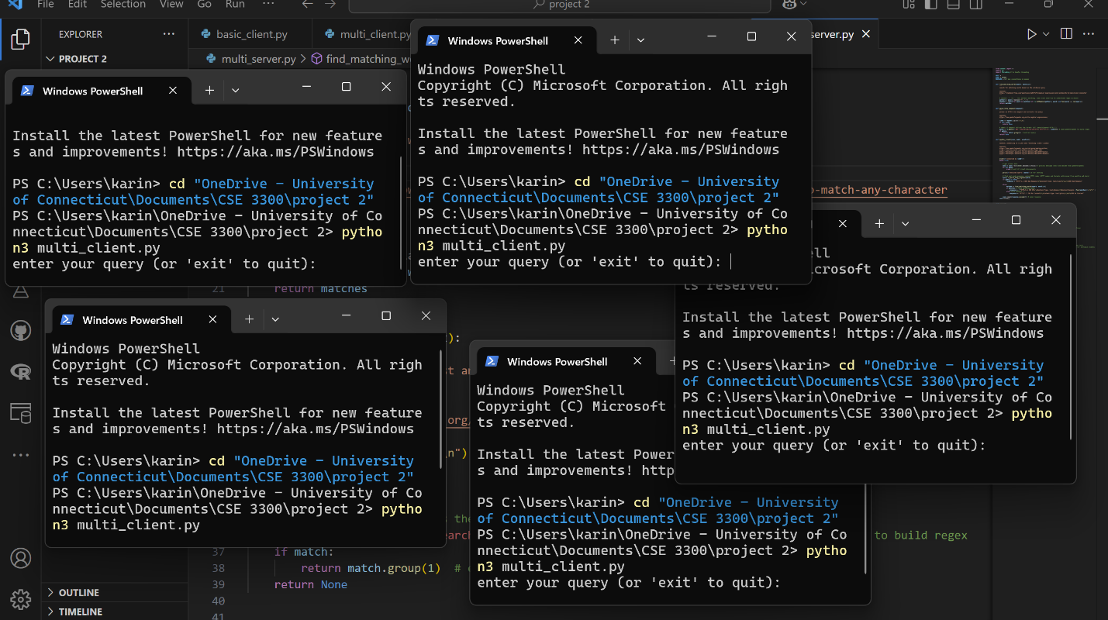

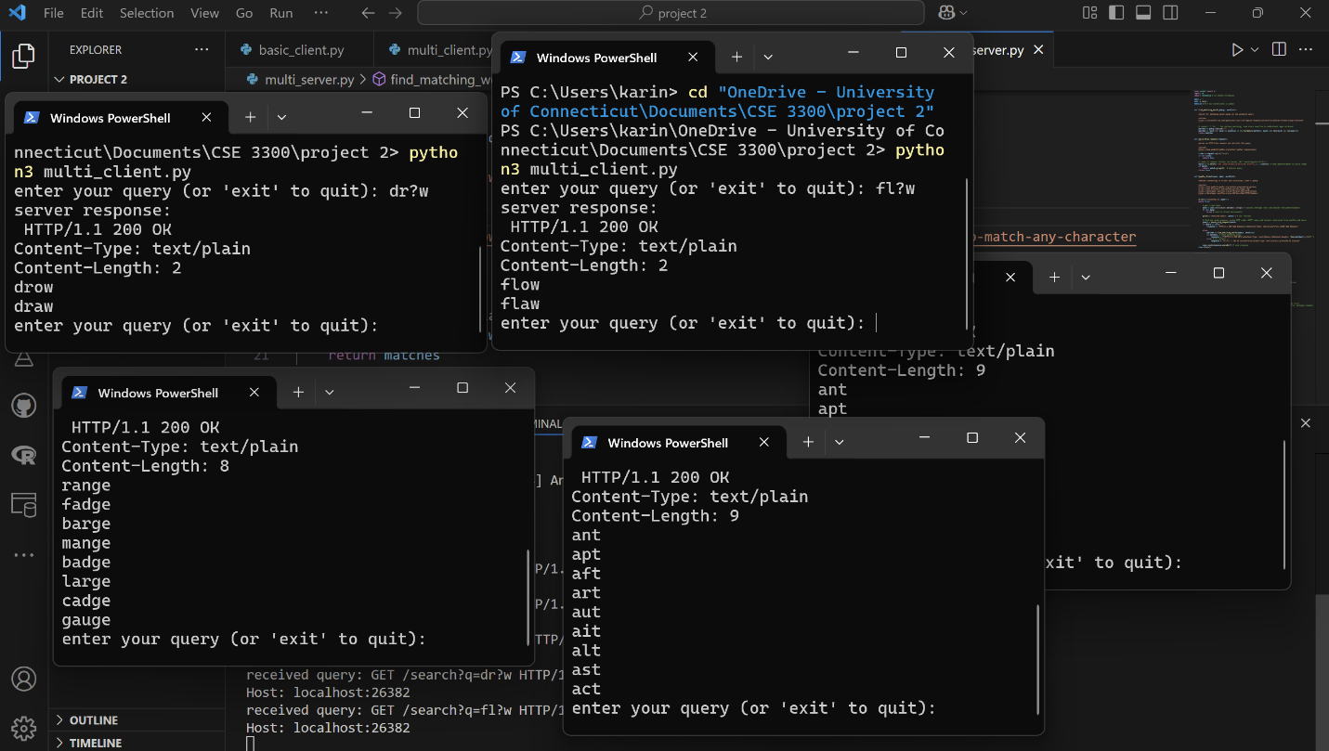
Second test: making sure all of them were able to successfully query. All of the clients I connected to the server did successfully make queries and the server outputted all the queries as well.

Third test: all HTTP messages work. If I submit a valid query, it gives me a 200 OK and the list of words. If I submit a valid query but with no matches, it returns a 204 No Content. If I submit an invalid query, it throws a 400 Bad Request.
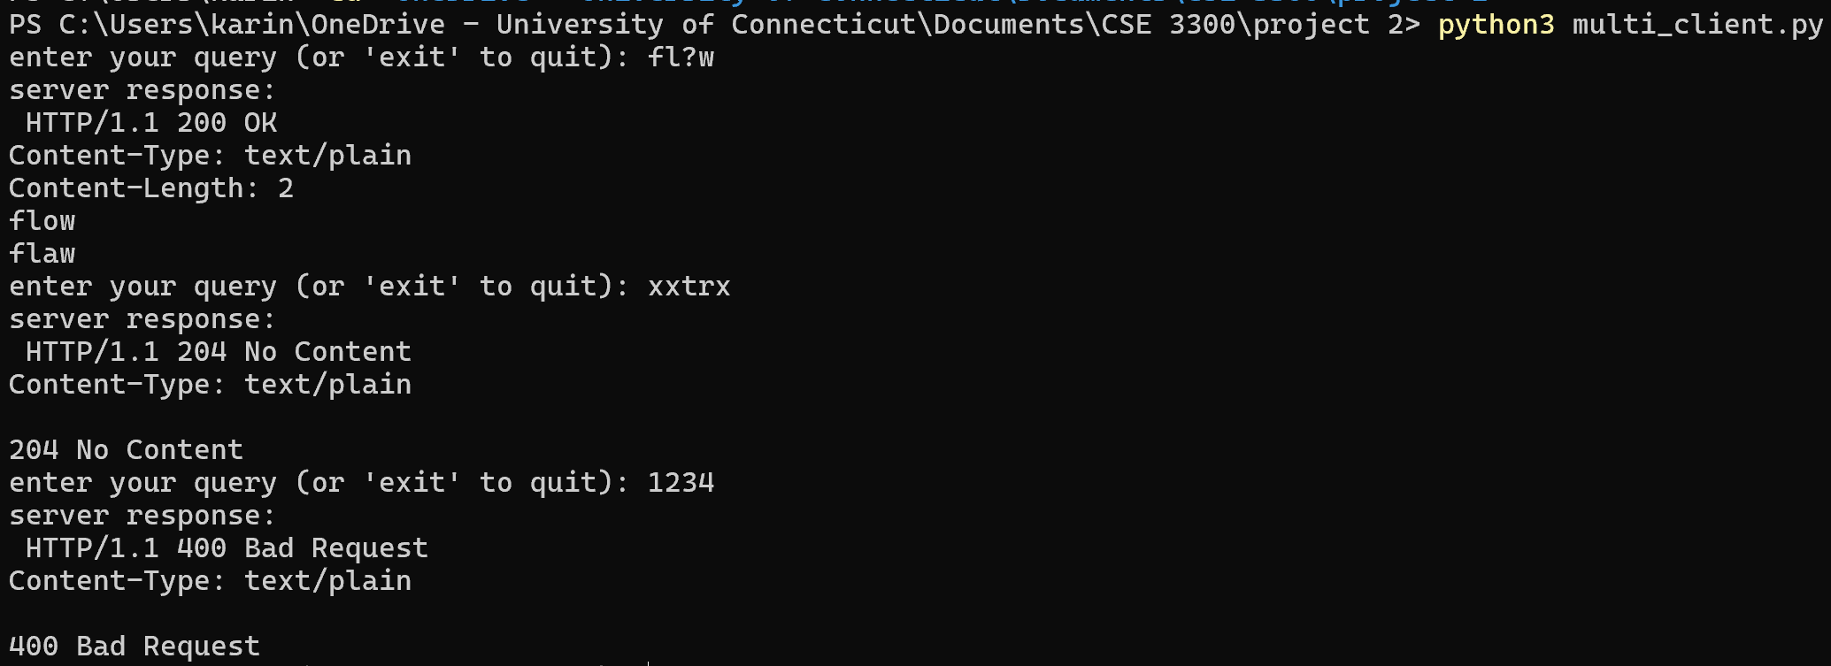

Fourth test: can handle multiple wildcards. I put 2 and 5 wildcards and it was able to return words that satisfied the query.
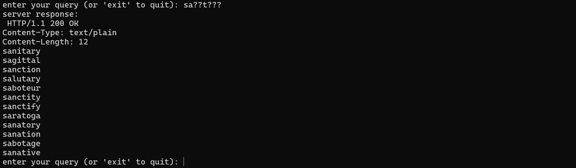
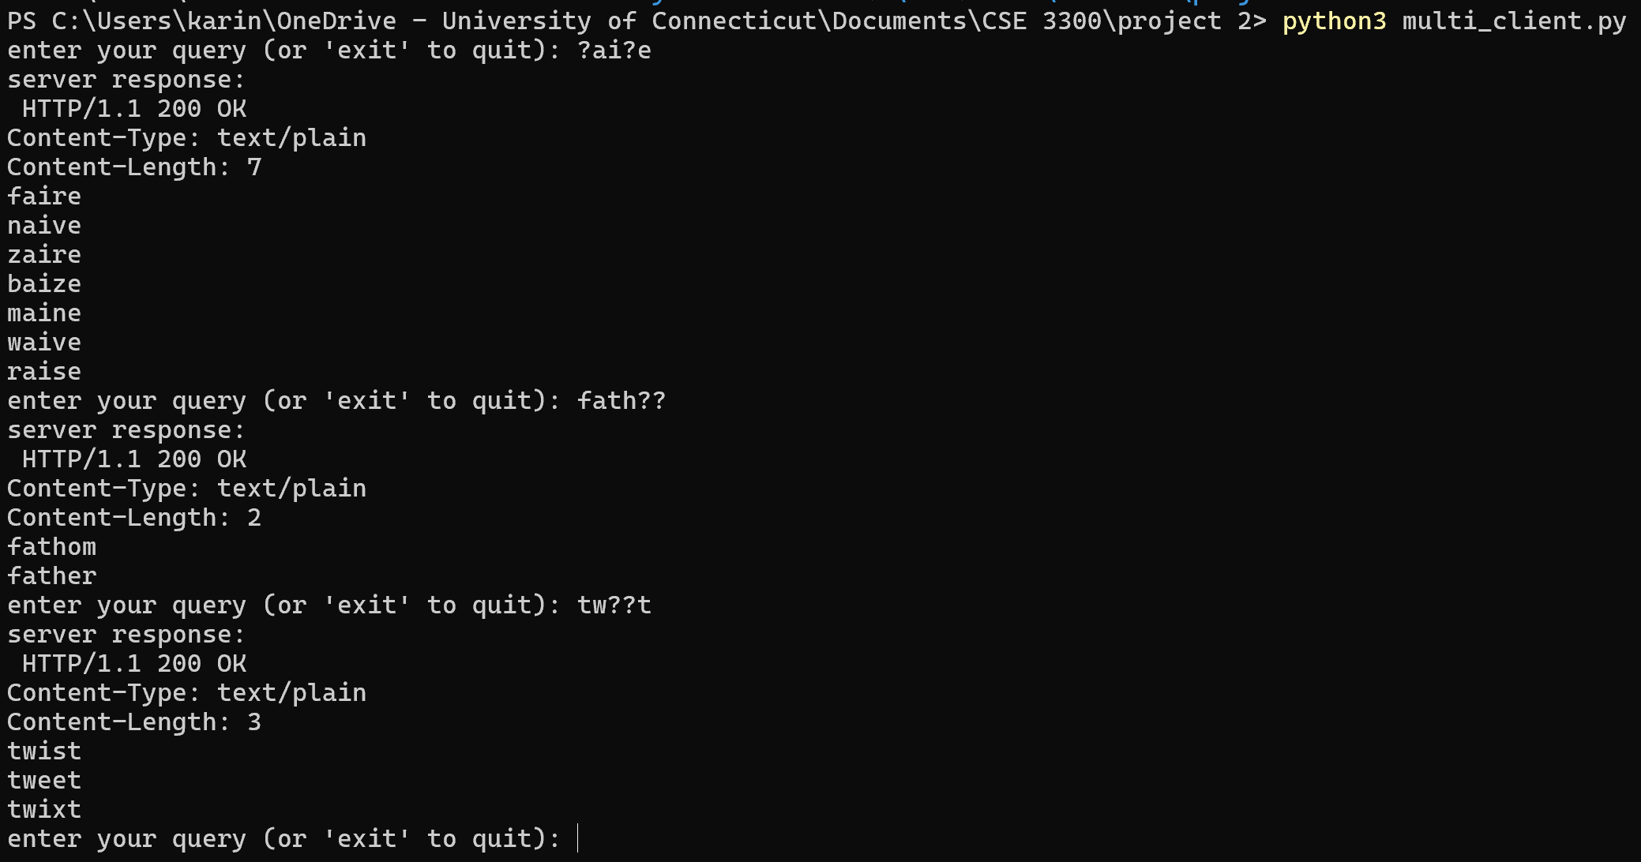

Fifth
Fifth test: case sensitivity. I did not implement handling cases so my server does not query properly when clients submit queries with uppercase characters.
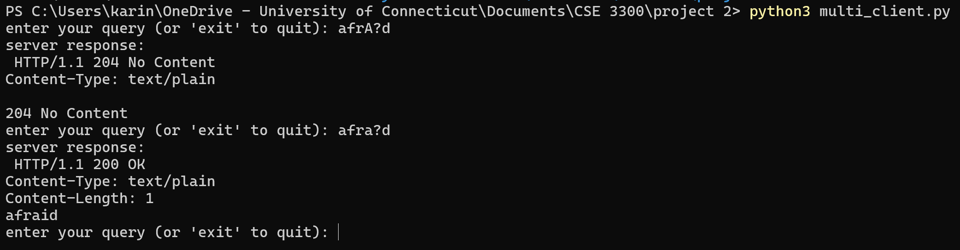

Sixth test: only wildcard characters. Submitting only wildcard characters does not break my server.
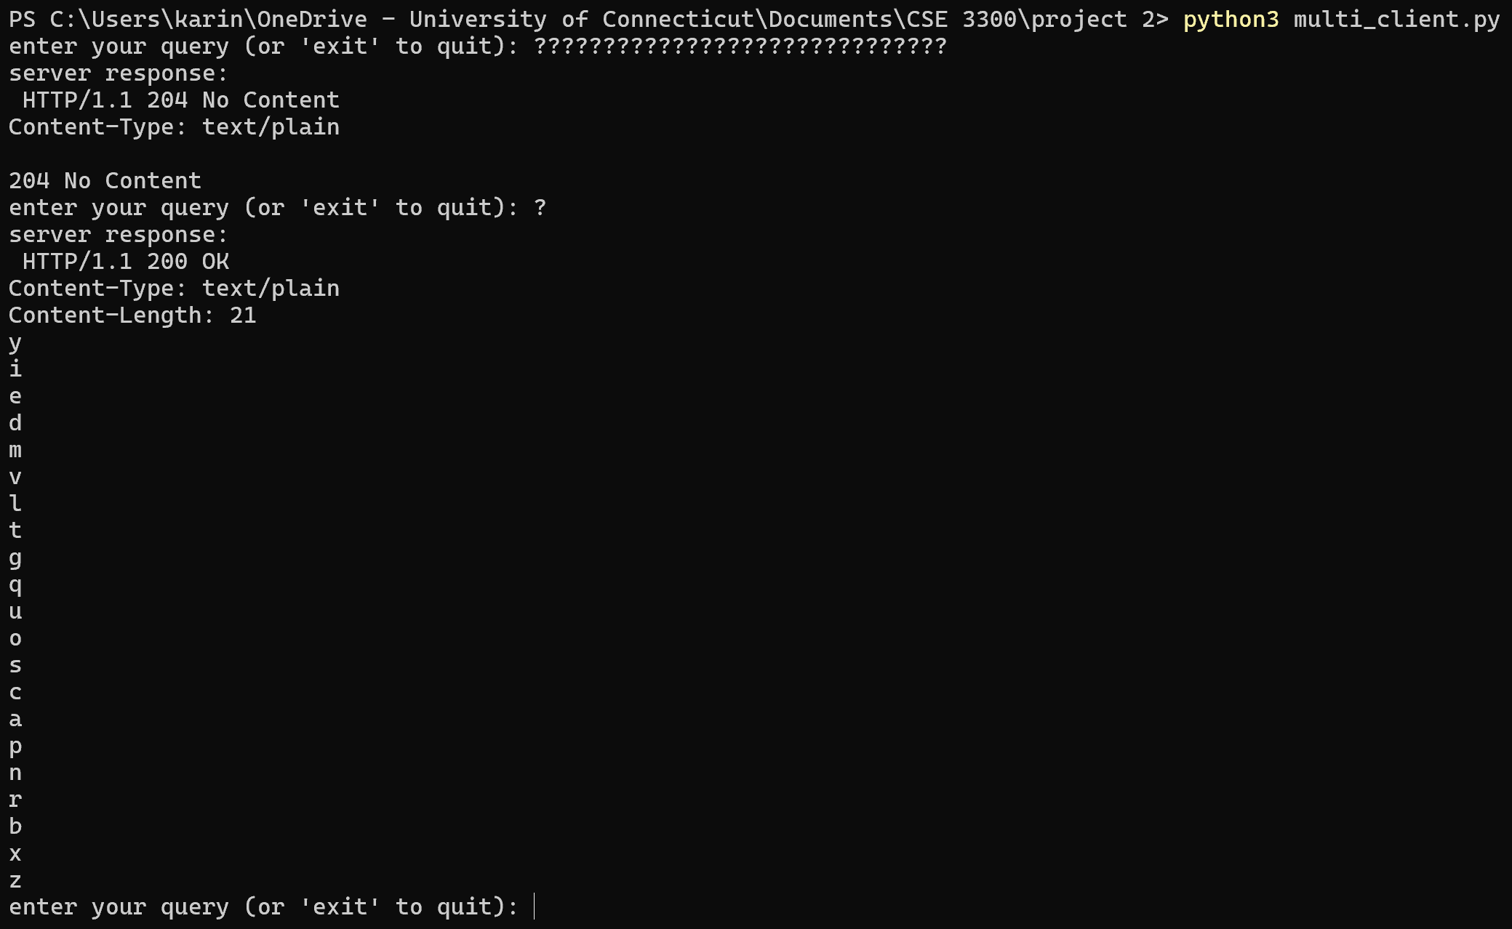

Seventh test: no wildcard characters. My server returns the exact word (if it is in the wordlist) when no wildcard is in the query.
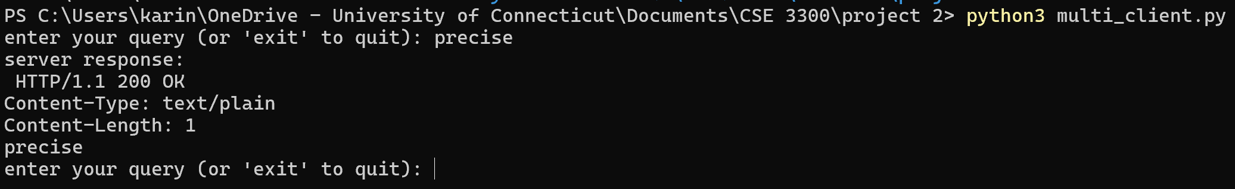

Extra Credit Test Cases:

This screenshot demonstrates that it will query for any size string that contains the substring a?t in it. I could not fit all the output, but the Content-Length shows that there were 4260 words.
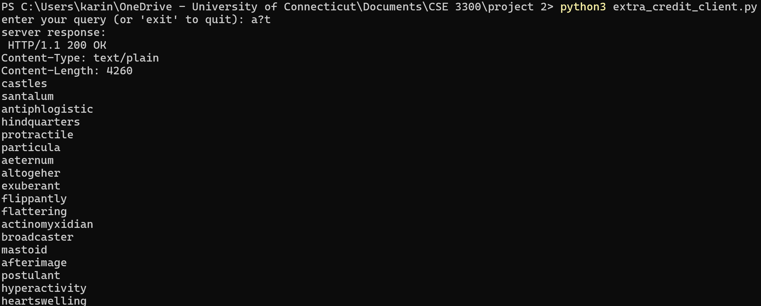

If I just submit a wildcard, it outputs all 69,903 words in the wordlist.
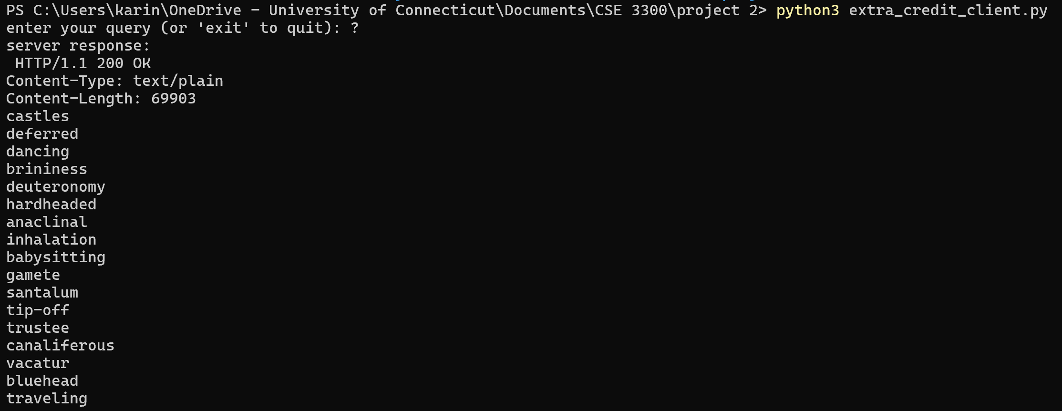

In this, you can see that the content-length header accurately shows the number of words outputted, as well as also shows that it gets both words that contain “pr?perly” in the wordlist.
